**CSC 250 – Program Design Document**

**John Akujobi – P8 IntList – SP2023**

**Structure Chart**

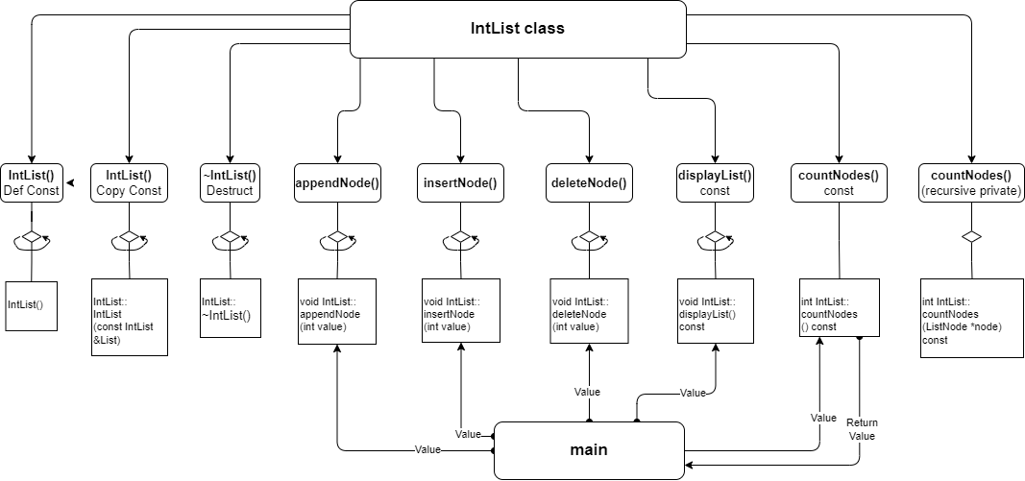

**Function Design (give the prototype and a short description for each function)**

1. IntList()
   * Default constructor. Initializes head to nullptr.
   * Parameters: None
   * Returns: None
2. IntList(const IntList &obj)
   * Copy constructor.
   * Loops through obj list and appends nodes to current list.
   * Parameters:
     + obj - IntList object passed by reference
   * Returns: None
3. ~IntList()
   * Destructor.
   * Deletes all nodes in the list.
   * Parameters: None
   * Returns: None
4. appendNode(int value)
   * Appends a node containing value to the end of the list.
   * Parameters:
     + value - integer value for new node
   * Returns: None
5. insertNode(int value)
   * Inserts a node containing value in the sorted list.
   * Parameters:
     + value - integer value for new node
   * Returns: None
6. deleteNode(int value)
   * Deletes a node containing value from the list.
   * Parameters:
     + value - integer value of the node to be deleted
   * Returns: None
7. displayList() const
   * Displays the nodes in the list.
   * Parameters: None
   * Returns: None
8. countNodes() const
   * Counts the number of nodes in the list.
   * Parameters: None
   * Returns: int
9. countNodes(ListNode *node) const (private)
   * A private recursive function to count nodes.
   * Parameters:
     + node - pointer to a ListNode
   * Returns: int

**Time Estimate**

|  |  |  |
| --- | --- | --- |
| **Function Name** | **Estimated Time** | **Actual Time** |
| Program Design | 3 hours | 2 hours |
| List each function and tine required |  |  |
| IntList() | 30 mins | 20 mins |
| IntList(const IntList &obj) | 30 mins | 10 mins |
| ~IntList() | 15 mins | 10 mins |
| appendNode(int value) | 15 mins | 10 mins |
| insertNode(int value) | 15 mins | 10 mins |
| deleteNode(int value) | 15 mins | 10 mins |
| displayList() const | 15 mins | 10 mins |
| countNodes() const | 15 mins | 10 mins |
| countNodes(ListNode *node) const (private) | 20 mins | 10 mins |
| Main Function int main() | 20 mins | 15 mins |
| Program Test | 1 hour | 20 mins |
| **Total Time** | **7 hours 10 mins** | **4 hours 15 mins** |